The effects of maternal SSRI exposure on the serotonin system, prefrontal protein expression and behavioral development in male and female rat offspring
Supplemental Information
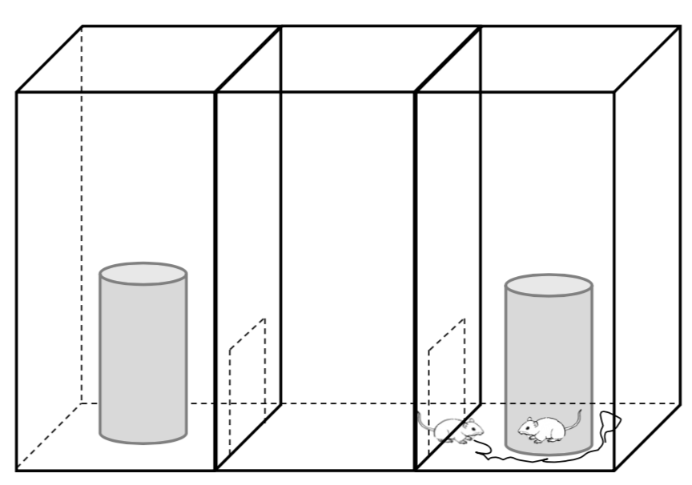
Figure S1. The wire cage with sticky note contained the strange rat. This picture shows that the experimental rat circled the strange rat.

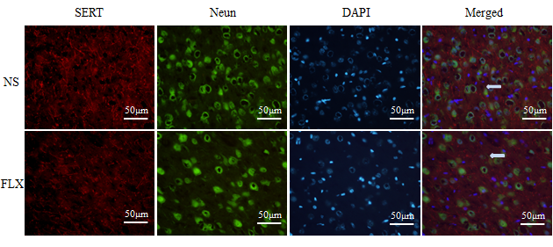
Figure S2. SERT expression in PFC in male (E) at PND 35 using immunoﬂuorescence (IF) technique
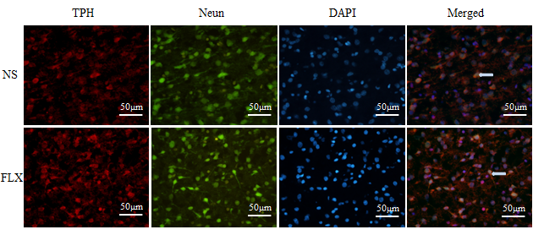
Figure S3. TPH expression in PFC in male offspring at PND 35 using immunoﬂuorescence (IF) technique.

